Computer configuration and Software installation

1-To check my ram : free -h
it means I have a total memory of 14 GB and 6.9GB is free. The ram is the memory used by the computer to perform operation and work.
2-To see the GPU : lspci | grep -i vga
It means the GPU is an AMD/ATI Barcelo (Radeon integrated).
3- To see my ubuntu version : lsb_release -a

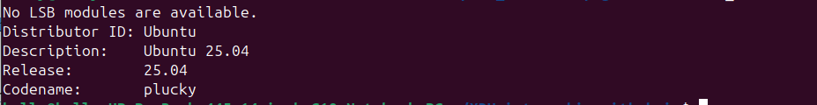
4-TO check the disk space : df -h /
The disk is about the storage.
5- To Clean up the computer :
# Remove unused packages
sudo apt autoremove -y

# Clean package cache
sudo apt clean

# Check how much you freed
df -h /

6- To upgrade the computer : sudo apt update && sudo apt upgrade -y

My computer capacity :

OS | Ubuntu 25.04 | Too recent
RAM | 14 GB | Perfect
GPU | AMD Barcela | CPU mode only
Disk | 26 GB free | Enough
Drive | NVMe SSD | Very fast

The problem with computer characteristics :
-My GPU is CPU only
CPU (Central Processing Unit) is the main brain of your computer, it does all tasks but one at a time, and my AMD laptop has 8-16 cores . But the GPU (Graphics Processing Unit) is a specialized processor for parallel tasks, so tit does thousands of tasks simultaneously, for example NVIDIA GPUs have 1000-10000 CUDA cores.

For AI training we need thousands of parallel calculations at the same time and it is what GPU does.

But the car we want to use is the LIMO PRO which has the following characteristics

Processor | NVIDIA Orin Nano
GPU cores | 1024 CUDA cores
AI power | 40 TOPS
RAM | 8 GB LPDDR5
Storage | 64 GB eMMC
Solution :
My own computer can’t be used for YOLOv5s Training because of its lacks of GPU, but I can do the YOLOv5s Training directly on the LIMO according to its characteristics.

-My Ubuntu version is too recent
In deed we need an Ubuntu 20.04 (Focal) for ROS1 and an Ubuntu 22.04 for ROS2.

Solution :
We will use Docker and work on it. We can directly work on the LIMO, but we choose to work on Docker to be enable to continue the work outside the Lab.

Languages and Software installation

1-Python :
OpenCv need : python 3.13
YOLOv5s need : Python 3.11
ROS need : python 3.8

Python version on computer :
To see my Python version : python --version
This version only match with OpenCV.
Solution : We will install Python 3.11 for YOLOv5s and for ROS we don’t need because Python 3.8 is needed where ROS Noetic and ROS Noetic is in Docker.
Python 3.11 installation : sudo apt install -y python3.11 python3.11-venv python3.11-dev

-python 3.11 : interpreter itself
-python3.11-venv : allows to create virtual environments to Isolate the project packages so OpenCV and YOLOv5s don't conflict with the system packages
-python3.11-dev : allow to develop headers needed to compile OpenCV properly

=>error during installation :
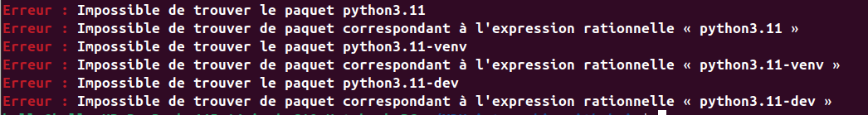
This problem come from the absence of Python 3.11 in the default repository of Ubuntu 25.04 I have, so to continue the installation we need to add it.

Add the deadsnake repository :
sudo apt install -y software-properties-common

Python 3.11 installation :

sudo apt update Atteint : 1 http://archive.ubuntu.com/ubuntu plucky InRelease Atteint : 2 http://archive.ubuntu.com/ubuntu plucky-updates InRelease Atteint : 3 http://security.ubuntu.com/ubuntu plucky-security InRelease Atteint : 4 http://archive.ubuntu.com/ubuntu plucky-backports InRelease Ign : 5 https://ppa.launchpadcontent.net/deadsnakes/ppa/ubuntu plucky InRelease Atteint : 6 https://ppa.launchpadcontent.net/obsproject/obs-studio/ubuntu plucky InRelease Atteint : 7 https://ppa.launchpadcontent.net/ubuntu-toolchain-r/test/ubuntu plucky InRelease Err : 8 https://ppa.launchpadcontent.net/deadsnakes/ppa/ubuntu plucky Release 404 Not Found [IP : 185.125.190.80 443] Erreur : Le dépôt https://ppa.launchpadcontent.net/deadsnakes/ppa/ubuntu plucky Release n'a pas de fichier Release. Notification : Les mises à jour depuis un tel dépôt ne peuvent s'effectuer de manière sécurisée, et sont donc désactivées par défaut. Notification : Voir les pages de manuel d'apt-secure(8) pour la création des dépôts et les détails de configuration d'un utilisateur.

Another normal error ! deadsnakes PPA doesn't support Ubuntu 25.04 yet.
┌─────────────────────────────────────────────────────┐
│ │
│ Ubuntu 25.04 (Plucky) is TOO RECENT │
│ → deadsnakes PPA not updated yet for it │
│ → We need another solution │
│ │
└─────────────────────────────────────────────────────┘

Solution — Build Python 3.11 from source
This is the most reliable method. Run each command one by one :

Step 1 — Remove the broken deadsnakes repository
bash
sudo add-apt-repository --remove ppa:deadsnakes/ppa
sudo apt update

Step 2 — Install build dependencies
bash
sudo apt install -y build-essential zlib1g-dev \
libncurses5-dev libgdbm-dev libnss3-dev \
libssl-dev libsqlite3-dev libreadline-dev \
libffi-dev curl libbz2-dev

Step 3 — Download Python 3.11 source code
bash
cd /tmp
curl -O https://www.python.org/ftp/python/3.11.9/Python-3.11.9.tgz

Step 4 — Extract the source code
bash
tar -xzf Python-3.11.9.tgz
cd Python-3.11.9

Step 5 — Configure the build
bash
./configure --enable-optimizations
⚠️ This takes 2-3 minutes

Step 6 — Compile Python 3.11
bash
make -j$(nproc)
⚠️ This takes 5-10 minutes depending on your CPU
┌─────────────────────────────────────────────────────┐
│ nproc = uses ALL your CPU cores simultaneously │
│ → Compiles as fast as possible │
│ → You will see lots of output — normal ! │
└─────────────────────────────────────────────────────┘

Step 7 — Install Python 3.11
bash
sudo make altinstall
⚠️ We use altinstall and NOT install
┌─────────────────────────────────────────────────────┐
│ altinstall = installs Python 3.11 WITHOUT │
│ replacing your default python3 (3.13) │
│ │
│ install = would REPLACE your system Python │
│ → could BREAK Ubuntu 25.04 ! │
│ → NEVER use plain install │
└─────────────────────────────────────────────────────┘

Step 8 — Verify installation
bash
python3.11 --version
Expected :
Python 3.11.9 ✅

Step 9 — Install pip for Python 3.11
bash
curl -sS https://bootstrap.pypa.io/get-pip.py | python3.11

Step 10 — Verify pip
bash
python3.11 -m pip --version
Expected :
pip 24.x.x from ... (python 3.11) ✅
┌─────────────────────────────────────────────────────┐
│ │
│ Repository method → fast but depends on │
│ someone packaging it for your Ubuntu version │
│ → Not available for Ubuntu 25.04 yet │
│ │
│ Build from source → always works │
│ → Download directly from python.org │
│ → Compile specifically for your machine │
│ → 100% reliable on ANY Ubuntu version │
│ → Used by professional developers │
│ │
└─────────────────────────────────────────────────────┘

-------------------- The environment of work (robot_project------------------------------------------------
# ENTER the environment
source ~/robot_project/bin/activate
→ (robot_project) appears ✅

# EXIT the environment
deactivate
→ (robot_project) disappears

# Re-enter anytime
source ~/robot_project/bin/activate
→ (robot_project) appears again ✅

